**EDLD 610 – Ouafaa Hmaddi**

**Proposal**

# Description of the data source

I will use the [public dataset](https://www.kaggle.com/kiva/data-science-for-good-kiva-crowdfunding) of Kiva’s microfinance loans. Kiva, established in 2005, allows lenders from around the world to provide small loans to borrowers, primarily in developing countries, who need these loans to fund projects that can serve several functions such as agricultural (purchasing a buffalo to increase milk sales) and educational (paying for a child’s tuition fees). I will use the loans data disbursed on 2014. I choose 2014 as the dataset is public on Kaggle as part of completion project: Data science for social good. However the purpose of this portfolio is different than the subject of the competition.

I will also use the inequality index GINI data of year 2014 [available on the World Bank](https://data.worldbank.org/indicator/SI.POV.GINI) website.

Both data sets have the countries codes although in different format but can be joined if both are transformed to an ISO code.

# Preliminary ideas of different visualizations

The general purpose of these visualizations to understands the dynamics of micro finance projects:

* where they are located over the world,
* how the loans are used and
* how long od these projects takes to be funded and paid back
* the relationship between micro finance and inequality
* how do we communicate about micro finance projects

## Visualization 1

This first visualization gives an overview of Kiva loans: locations over the world, sectors targeted and the overall terms of projects. Other potential related graphs, such as gender distribution could be added to get an overall idea about the loans. This group of visualizations targets a large audiences of social scientists as well as people in general who are interested in putting their money into Kiva micro finance project and would like to get a quick overall view about these projects.

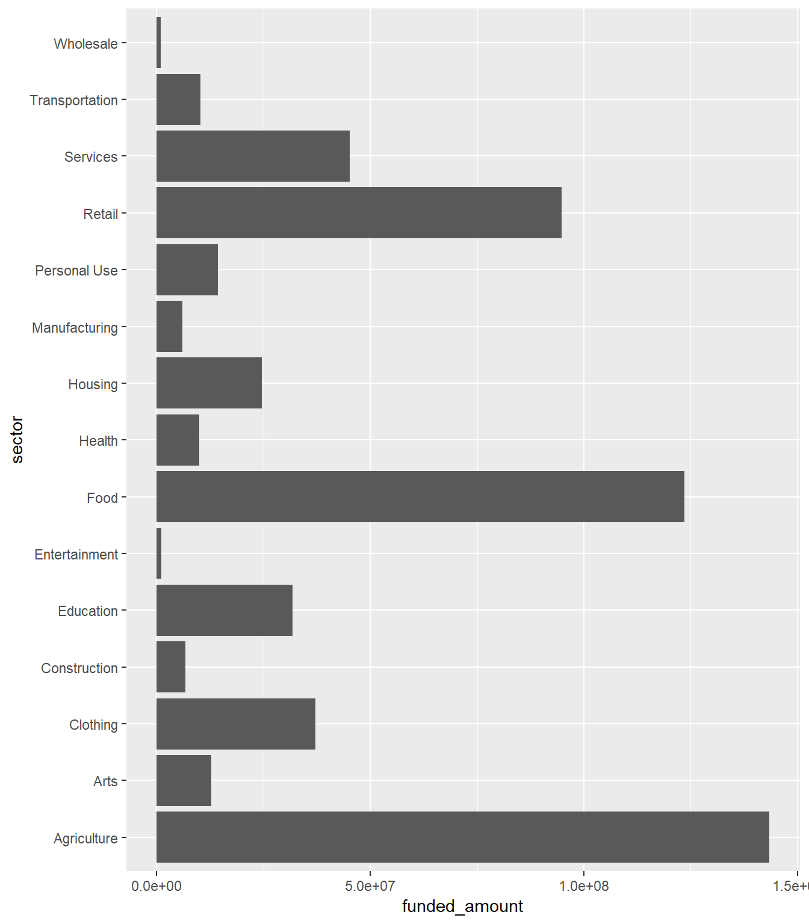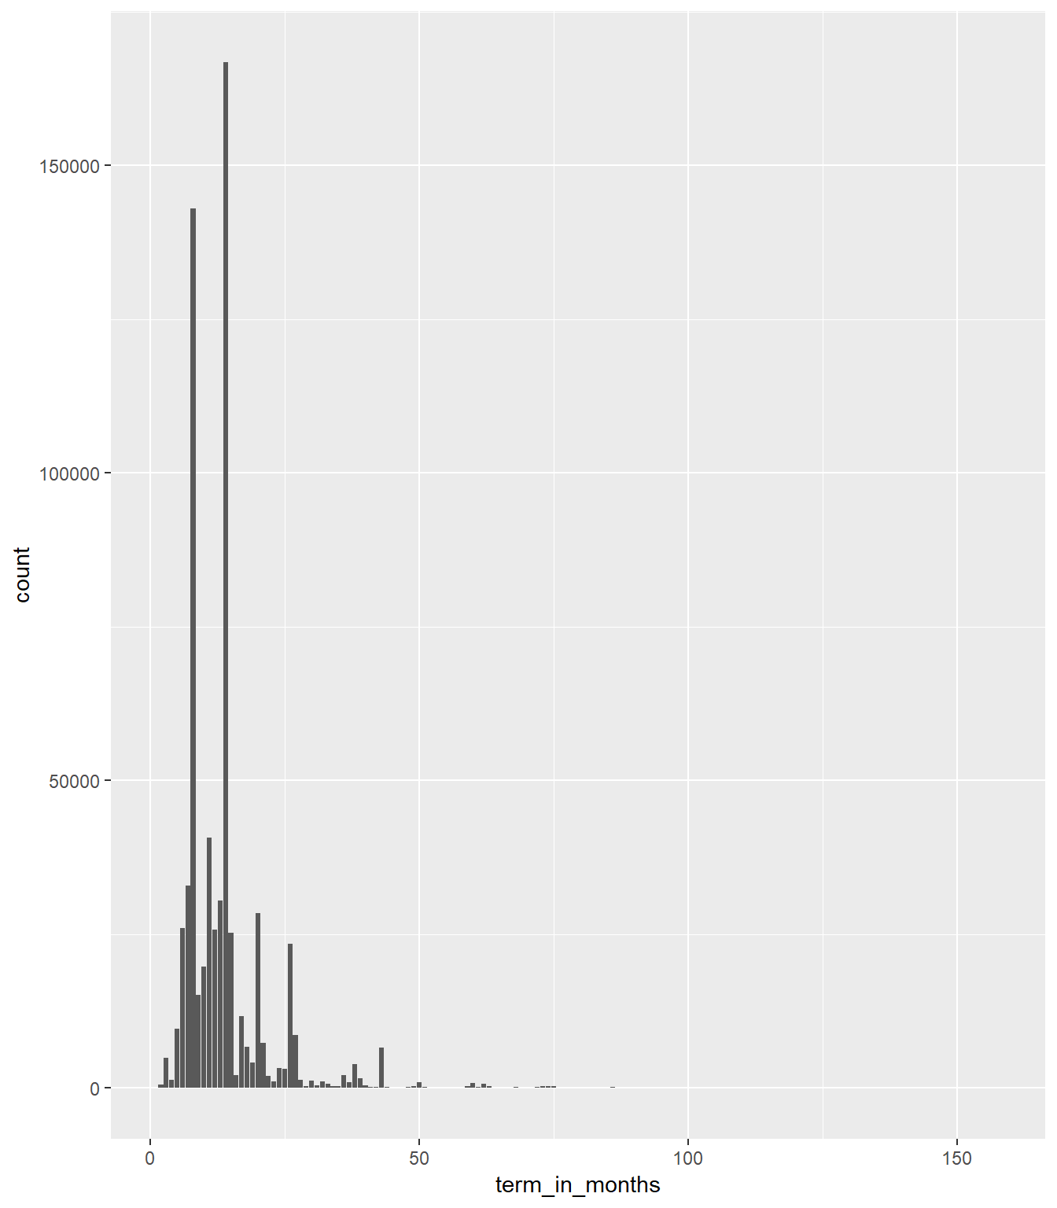

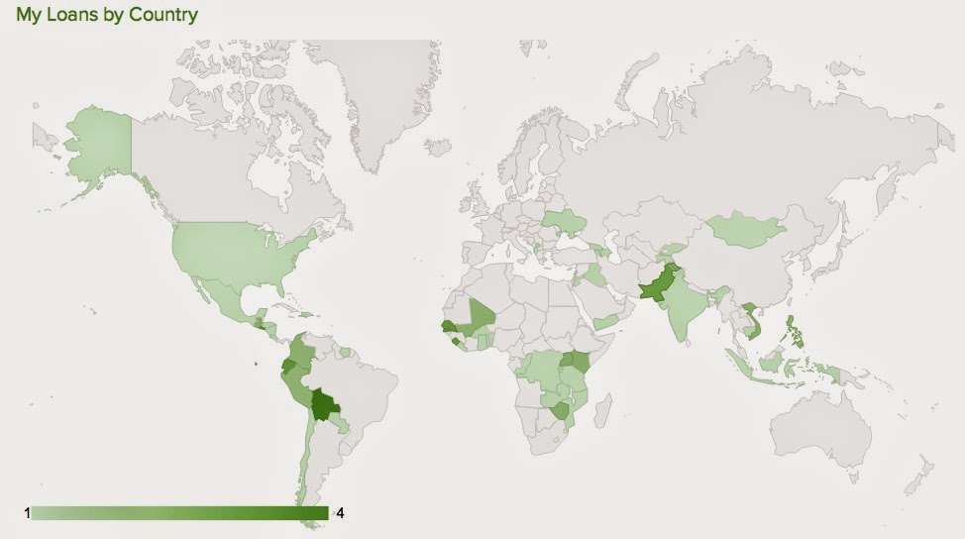

## Visualization 2

The purpose of this visualization is to compare the way people communicate about micro finance projects and the way the beneficiaries describe these projects. As we can see from the preliminary visualization below, we tend to use a lot of non-relevant buzzwords in communicating about these projects. Another important use of the visualization on the left, is too see how these loans are used. I was hoping for invest to be main word instead of buy and purchase, because investing in these money is the only way we can improve the situation of these marginalized populations.

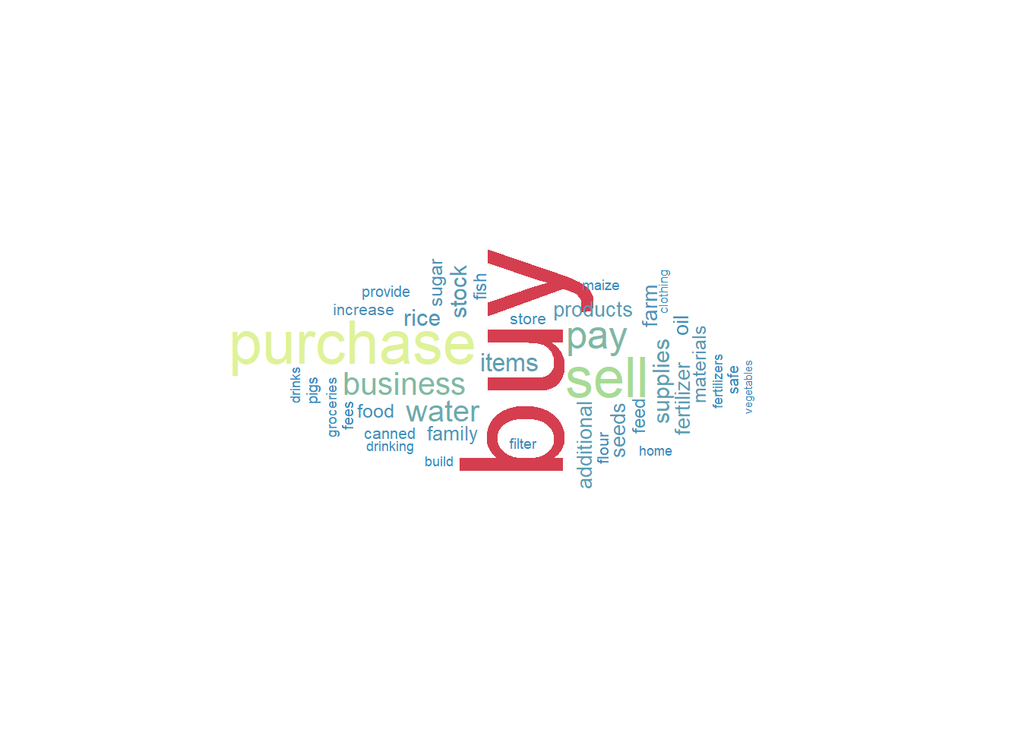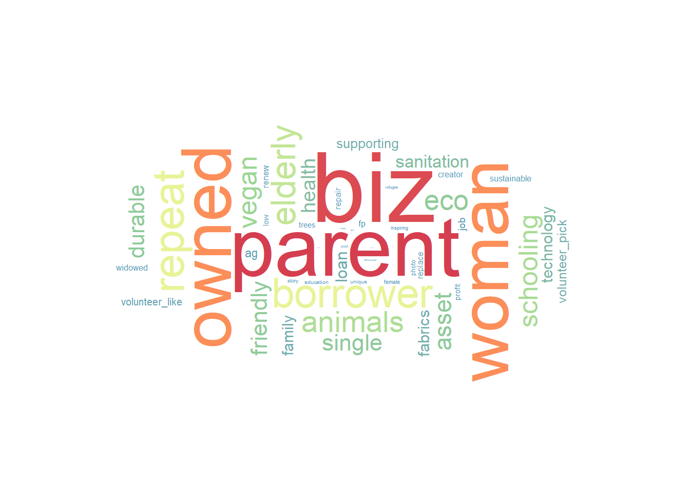

## Visualization 3

The purpose of this visualization is to evaluate the relationship between inequality and the funding of micro finance projects. There is probably a better way to show this relationship and I could probably add another scale.

